3rd Grade
*Backpack
- 1 Pair Earbuds or headphones
- 4 packs Expo dry erase black markers
- 60 Ticonderoga Pencil pack
- 24 pack Crayola crayons
- 4 Glue sticks
- 4 Large erasers
- 1 Pair of scissors
- 10-12 Thin pack of colored markers
- 2 Packages of copy paper
- 5 Wide ruled composition notebooks (no spiral notebooks please)
- 1 Package of Wide ruled notebook paper
- 4 Pocket folders
- 2 Containers disinfectant wipes
- 2 Box of tissues
- 1 Container of hand sanitizer
- 1 Box of 24 count colored pencils

4th Grade
*Backpack
- 1 Pair Earbuds or headphones
- 4 pack Expo dry erase black markers
- 48 Ticonderoga Pencil pack
- 1 Large glue sticks
- 4 Large erasers
- 2 Pads Post-its (3”x3”)
- 2 Wide ruled composition notebooks
- 1 Package of copy paper
- 2 Spiral notebooks
- 2 Packages of wide ruled loose leaf paper
- 1 Package ballpoint pens, blue or black
- 4 Pocket folders
- 1 Bottle hand sanitizer
- 2 Box of tissues
- 1 Container Clorox wipes

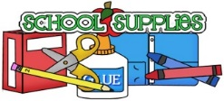

5th Grade
*Backpack
- Clorox wipes
- 2-3 folders
- Erasers
- 1 Pair of Earbuds
- 48 Ticonderoga Pencil pack
- 4 pads Post-its (3”x3”)
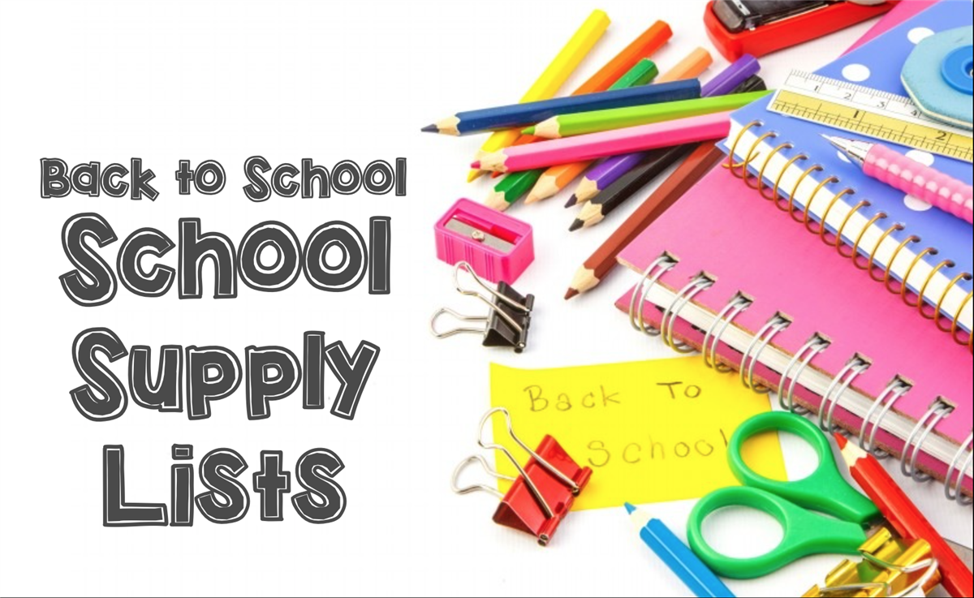
- 2 Spiral notebooks
- 2-3 Packages of Wide ruled loose leaf paper
- 2 packs Dry Erase markers
- 2 Boxes of tissues
- 1 Container of hand sanitizer

Preschool and ILC
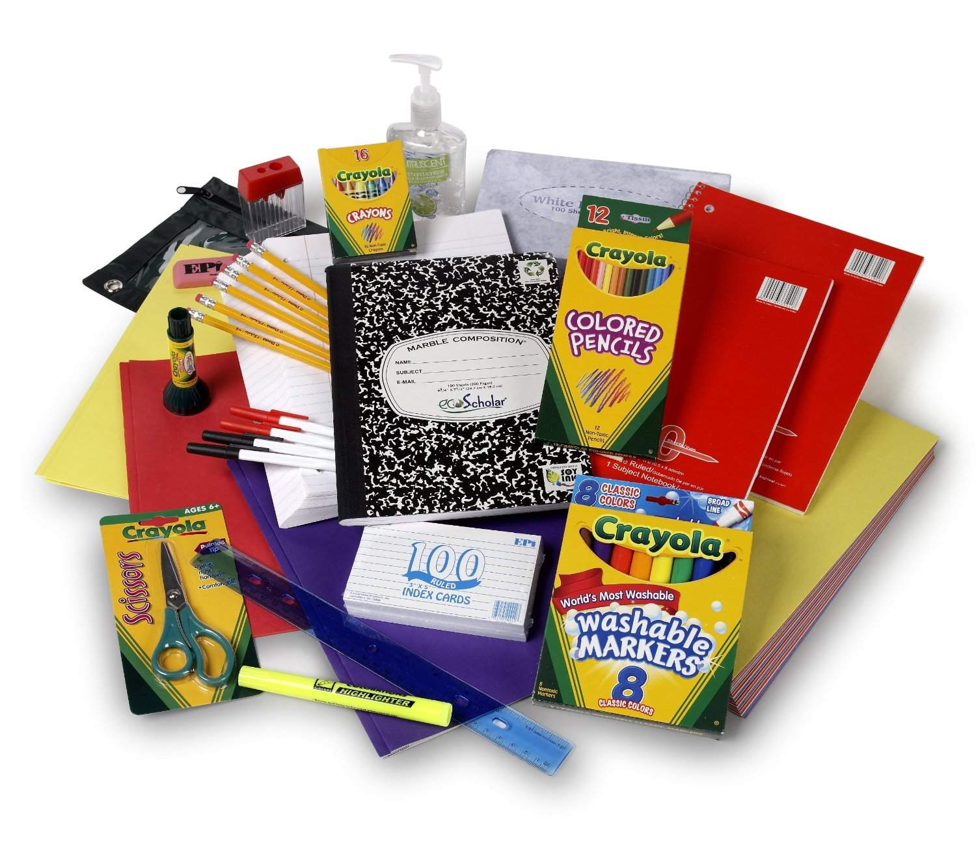
*Backpack
- 2 Boxes of tissues (Kleenex)
- 2 Notebooks
- 1 Folder
- 3 Pkgs. Crayons/markers
Pencils & dry erase markers
- Lysol wipes
- 1 Box of snacks that feed 10 (goldfish, pretzels, etc.)

